Victorian Curriculum F–10 links:
Levels 5 and 6
History
Historical Knowledge
The Australian colonies
The nature of convict or colonial presence, including the factors that influenced changing patterns of development, how the environment changed, and aspects of the daily life of the inhabitants, including Aboriginal and Torres Strait Islander peoples
The effects of a significant development or event on a colony
Science
Science Understanding
Science as a Human Endeavour
Scientific understandings, discoveries and inventions are used to inform personal and community decisions and to solve problems that directly affect people’s lives
Biological sciences
Living things have structural features and adaptations that help them to survive in their environment
The growth and survival of living things are affected by the physical conditions of their environment
Chemical sciences
Solids, liquids and gases behave in different ways and have observable properties that help to classify them
Changes to materials can be reversible, including melting, freezing, evaporating, or irreversible, including burning and rusting
Earth and space sciences
Sudden geological changes or extreme weather conditions can affect Earth’s surface

From past to present—at the Western Treatment Plant (Years 5 and 6)
  - Lesson plan

Introduction
This lesson plan focuses on the historic development of Melbourne’s sewerage system and the Western Treatment Plant. The activities include an introduction to the terms used in the sewage treatment, the processes involved and the importance of treating sewage before discharge into Port Phillip Bay or so it can be recycled for other purposes. Using a historical context students develop an understanding of the events that led to the development of a sewerage system.
Students apply their understandings about sustainability and use a set of questions to guide their inquiry about sustainable approaches used at the Western Treatment Plant.
For information about tours of the Western Treatment Plant, go to Visit the Western Treatment Plant at <http://www.melbournewater.com.au/getinvolved/education/programs/WTPtours/Pages/Visit-the-Western-Treatment-Plant.aspx>

Activity 1: Step back in time
Students use an historical perspective to describe the events that led to the development of the Melbourne sewerage system and Western Treatment Plant.

Activity 2: Sewage: Mainly solid or mainly liquid?
Students learn that sewage is mostly liquid.

Activity 3: How would we treat sewage?
Students draw on their knowledge about removing solids from water and apply those ideas to predict the types of processes are used at the Western Treatment Plant and how they might be carried out.

Activity 4: Treating sewage sustainably
Students investigate the sustainable practices used at the Western Treatment Plant and the related benefits and impacts on society and the environment.

Activity 5: How does the Western Treatment Plant work?
Students explore the key processes used to treat sewage and develop a flow chart to describe the process.

Activity 1: Step back in time
Students use an historical perspective to describe the events that led to the development of the Melbourne sewerage system and Western Treatment Plant.

Duration
Two-hour session
Activity steps
- Pose the following questions:
- What would Melbourne have been like before European settlement?
- What was life like growing up in the 1880s?
- What would people have done with their waste including their rubbish, recycling and sewage?
- Focus students’ thinking on housing, transport, food, clothing, streets and buildings, and how these may differ from today.
- Use digital resources to help students gain a sense of what it was like to live in Melbourne during these times. Useful resources include:
  - View the following resources in Scootle at <https://www.scootle.edu.au/ec/p/home>. Teachers can register for free with their school email address.
- R3347 Collins Street, Melbourne, 1889 (painting) The painting Collins Street, Melbourne, 1889 portrays a street filled with activity of the people of that era, the forms of transport used (tram, wagon and horseback) and the street paved with flagstones.
- R6401 'Your house and mine', 1954 - asset 12 (film clip) The film clip 'Your house and mine' provides a look at the backyard lanes and backyard toilets and is a reminder of how things would have been when ‘nightmen’ collected the nightsoil.
  - View clips of early Melbourne to discuss lifestyle and what it might have been like to live in Melbourne in the early 1900s:
Marvellous Melbourne: Queen City of the South, circa 1910, Australian Screen website, <http://aso.gov.au/titles/documentaries/marvellous-melbourne/>
  - View maps, images of the people, early works and information about the Board of Works at <http://www.cv.vic.gov.au/stories/built-environment/melbourne-and-smellbourne/>
  - The video ‘The urinal’ is an introduction to early Melbourne’s human waste problem and the events that lead to the design and building of the sewage system and Western Treatment Plant. See ‘The urinal’, <https://museumsvictoria.com.au/melbournemuseum/learning/school-programs-and-resources/dunny-detectives-excavating-little-lon-self-directed/dunny-detectives-back-at-school-activities/>
- Follow up the video with the Student worksheet: Melbourne to Smellbourne and how it cleaned up its act. Organise students to work in pairs, for example pairing up students with differing literacy levels, to read the texts and organise them into a chronological order of events using cues in the text.
- Lead discussion about the following questions:
- What ‘major problem’ did Melbourne have in the 1880s?
- What did the ‘nightman’ do?
- What is the Melbourne Metropolitan Board of Works? Why was it formed? What did it do?
- What would our life be like if we did not have a sewerage system?
- Students use the following sources from the Melbourne Water website to refine the sequence of events that they developed in pairs:
- History of sewerage <http://melbournewater.com.au/aboutus/historyandheritage/historyofsewerage/Pages/history-of-sewerage.aspx>
- Our history - a timeline <http://melbournewater.com.au/aboutus/historyandheritage/Pages/Our-history-a-timeline.aspx>
- History of the Western Treatment Plant <http://melbournewater.com.au/aboutus/historyandheritage/historyofsewerage/Pages/History-of-the-Western-Treatment-Plant.aspx>
- After finalising the sequence of events, each pair of students could create a book using the text as a basis and illustrate pages to support it.

Extension activities
How did the life of Aboriginal people differ from that of the Europeans who settled Melbourne?
Find out more about a waterborne disease such as typhoid and diphtheria.

Resources about the history of sewerage
Night Soil, Kingston Historical Website, <http://localhistory.kingston.vic.gov.au/htm/article/30.htm>

Activity 2: Sewage: Mainly solid or mainly liquid?
Students explore models that demonstrate the proportion of solids to liquid in sewage.

Duration
One hour session

Equipment
1L soft drink bottle filled with water
1L soft drink bottle filled with half water and half solids (grass clippings, soil and shredded paper)
A range of containers and measuring cups and materials for use as solids such as sand, soil and shredded paper

Activity steps
- Show the students the 1 L soft drink bottle filled with water. Explain that the bottle contains 100% water.
- Show the second 1 L soft drink bottle filled with half water and half solids (grass clippings, soil and shredded paper). Lead students to describe the amount of water as a percentage (50% water).
- Ask students to stand on a line marked in the classroom to indicate the percentage of water they think makes up sewage. Identify one end as 0% and the other as 100%. Select several students along the line to give a reason for their position on the continuum. Explain that sewage is 99% water and 1% solid. Discuss where the sewage comes from, for example, toilet, showers and baths, laundry, kitchen sinks and industrial waste.
- Organise students to work in groups of three or four to create a model showing 99% water and 1% solid. Provide access to a range of containers and measuring cups and materials for use as solids such as sand, soil and shredded paper. Students explain their approach to creating an accurate model.

Teacher background
Sewage typically contains around 99% water. The impurities in sewage are as follows:
- micro-organisms— often including disease-causing organisms (pathogens) such as bacteria, viruses, protozoa and parasitic worms
- phosphorus compounds—these are present in human waste (faeces) and in detergents
- nitrogen compounds—these are mostly present as ammonia or urea
- suspended solids—including inert material such as sand and organic solids such as food scraps
- organic matter—this can include faeces, fats and oils
- additionally, sewage will contain rags, plastics, sanitary products and other large solids.

Waste from industry (trade wastes) can provide high levels of:
- fats and oils particularly from food outlets such as take-away shops, meat and fish shops, cafeterias and restaurants
- heavy metals, toxic materials and various organic compounds (e.g. pesticides and herbicides) from some industries can potentially limit the reuse of sludge (biosolids).
Activity 3: How would we treat sewage?
Students draw on their knowledge about removing solids from water and apply those ideas to predict the types of processes they may observe at the Western Treatment Plant and how they might be carried out.

Duration
One hour session

Activity
- Ask students what they would expect to see at the Western Treatment Plant. Lead discussion about:
- the types of large solids and suspended solids which may need
- to be removed and how that might be done
- how sewage might be moved around the plant
- how wastes are removed from sewage to end up with treated water that can be put back into the environment
- where the treated water ends up
- how long the entire process might take.
- List students’ ideas and question other students in order to ‘piggy back’ on someone else’s ideas. For example, if a student suggests that bits of plastic and solid objects need to be removed, ask another student to explain what they might see at the Western Treatment Plant that has this function. This type of strategy can be used to include those students reluctant to offer ideas as part of a class discussion.
- Ask students to draw a labelled diagram showing how they think the sewage will be treated, the types of items or substances that need to be removed, what processes might be involved, the machinery that may be used, and where the sewage goes after the treatment process.
- Display completed, labelled diagrams and look for common ideas and key processes to discuss as a class in further detail.
- Complete a class Y chart of what students might see, smell and hear.

Activity 4: Treating sewage sustainably
Students describe the sustainable practices used at the Western Treatment Plant and the related benefits and impacts on society and the environment.

Duration
Two-hour session

Equipment
Interactive whiteboard or data projector

Activity steps
- Discuss the term ‘sustainable’; this is a complex term for students to understand. Begin with brainstorming words or phrases that relate to being sustainable. Lead students to the understanding that sustainability is the wise use of resources, minimising waste and ensuring resources for future generations.
- Explore the Melbourne Water web page that explains the community and environmental benefits of the Western Treatment Plant at < https://www.melbournewater.com.au/community-and-education/about-our-water/sewage >. Ask students to list the ways in which the Western Treatment Plant is working towards being sustainable. Ideas include:
- methane gas is captured to power the plant
- dried-out sludge (biosolids) is used as fuel, road beds or soil for landscaping
- water is recycled in the process of treating the sewage
- water enters the atmosphere through evaporation and can return to the ground as rain
- a natural process is used to treat our sewage
- the wetland provides habitat for water birds.
- Ask students to choose an area of interest and find out more about the processes at the Western Treatment Plant that help us to live more sustainably.
- Use the following process to find out more about sustainable practices.
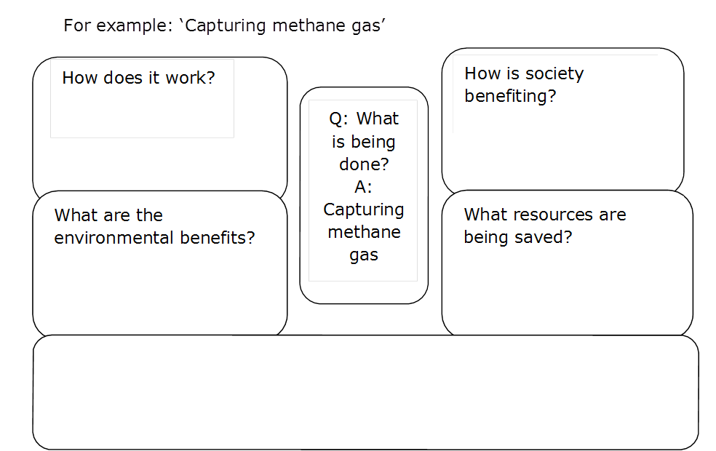
- Share students’ ideas about the sustainable practices identified and elaborated using the above inquiry method.
- Ask students to reflect on ways that they can become more sustainable with their own water use.

Activity 5: How does the Western Treatment Plant work?
Students describe the key processes used to treat sewage. They develop a flow chart to describe the process.

Duration
Two-hour session

Equipment
Interactive whiteboard or data projector

Activity steps
- Review student ideas about treatment processes at the Western Treatment Plant. Watch the Where does wastewater go? ABC Splash video [3:42] at <http://splash.abc.net.au/home#!/media/524873/>
- Ask students to describe which of the processes they correctly predicted they would expect to find at the Western Treatment Plant. Ask students to describe differences between what they expected to see and what they observed in the video. Refer to the Y chart of what they thought they would see, hear and smell. Update the chart with new ideas in a different colour.
- Using the information on the Sewage treatment process web page at <http://www.melbournewater.com.au/whatwedo/treatsewage/wtp/Pages/Sewage-treatment-process.aspx>, lead discussion to identify and elaborate on the key processes of sedimentation, aeration and evaporation. Show the animations listed in the Resources below to explain how micro-organisms (bacteria) enable the plant to treat water without chemicals. Key questions may include:
- How are large solids such as plastics and rags removed from sewage? (Sludge settles; the process is sedimentation.)
- What happens to the solids in the large pond? (Sludge settles; the process is sedimentation.)
- Why is one pond covered over with black plastic? (Bacteria in this pond feed on the sludge without oxygen and they produce methane gas when they break down the sludge. Waste gases are captured reducing smells and harmful greenhouse gas to the atmosphere).
- How is the waste gas used? (Methane is the waste gas captured and used to generate electricity to run the plant.)
- What happens to the sewage as it travels through the pond system? (Bacteria continue the process to break down the sewage. The sun evaporates some of the water, which enters the atmosphere as a vapour and becomes part of the water cycle.)
- What role do the big beaters play? (Provide oxygen; the bacteria in this pond need oxygen to feed on the sewage and break it down to remove nitrogen. The process when oxygen is mixed into the water is called aeration.)
- How are the bacteria removed from the water? (As the treated water passes through the ponds bacteria-filled sludge settles to the bottom and is collected and reused in the activated sludge plant in pond 5. In shallow water, ultraviolet (UV) light from the sun helps control harmful (pathogenic) bacteria. The ultraviolet light affects the bacteria causing them to lose their ability to reproduce and therefore die out.)
- What role do algae and zooplankton play in the treatment process? (Algae are microscopic green plants that use the sun’s light to grow. They produce oxygen and take up nutrients such as nitrogen. In turn, algae are eaten by zooplankton (microscopic organisms). Birds also feed on algae and zooplankton.)
- Why is the treatment process considered to be a natural one? (The bacteria are used to remove organic matter from the sewage rather than harmful and expensive chemicals.)
- Distribute the Student worksheet: Treating sewage. Students use the worksheet to create a flow chart of the treatment process. They could complete the activity as a poster adding their own text to describe the processes. Alternatively, the images could be provided electronically for students to use with presentation software.
Reflection
- Students compare their completed flow chart with their labelled diagram developed in the pre-activity. They use the two representations to describe their learning.
Note: This task could be used for assessment purposes to assess student understanding of the processes used to treat sewage. Key processes include sedimentation, evaporation and aeration.

Teacher background
Sewage treatment is a completely natural process using biological organisms rather than chemicals. The purpose of sewage treatment is to remove:
- organic matter
- suspended solids
- nutrients
- disease-causing organisms.
At the completion of the process only liquid effluent remains. This effluent is provided for various land uses or released to the ocean.

Resources
Where does wastewater go? ABC Splash
<http://splash.abc.net.au/home#!/media/524873/>
Western Treatment Plant, Melbourne Water
Primary treatment of sewage and anaerobic treatment of sludge
<https://www.youtube.com/watch?v=--GS_djOzcg&list=PL1zDcvEb76G6FdTMg-_VRmAE4jMoarrKr&index=1>
Secondary treatment of sewage
<https://www.youtube.com/watch?v=yF9hQUebDNA&index=2&list=PL1zDcvEb76G6FdTMg-_VRmAE4jMoarrKr >
Tertiary treatment of sewage at the Western Treatment Plant

<https://www.youtube.com/watch?v=_v39CRr8gGY&list=PL1zDcvEb76G6FdTMg-_VRmAE4jMoarrKr&index=4

Student worksheet: Melbourne to Smellbourne (Activity 1)
Cut out the text boxes. Put them in order to tell the story of Melbourne’s sewerage history.
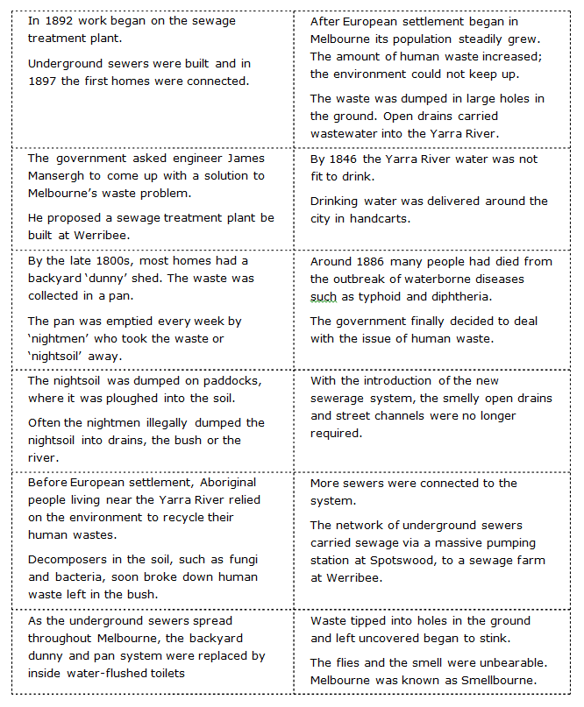

Student worksheet: Treating sewage (Activity 5)
Use these images to create a flow chart to describe how sewage is treated at the Western Treatment Plant.
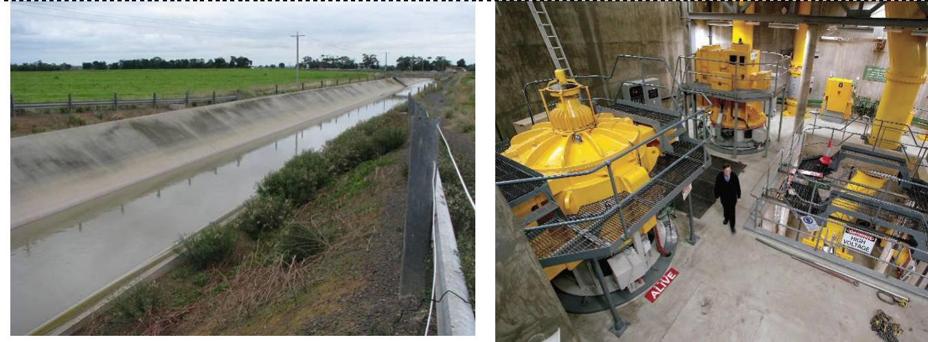
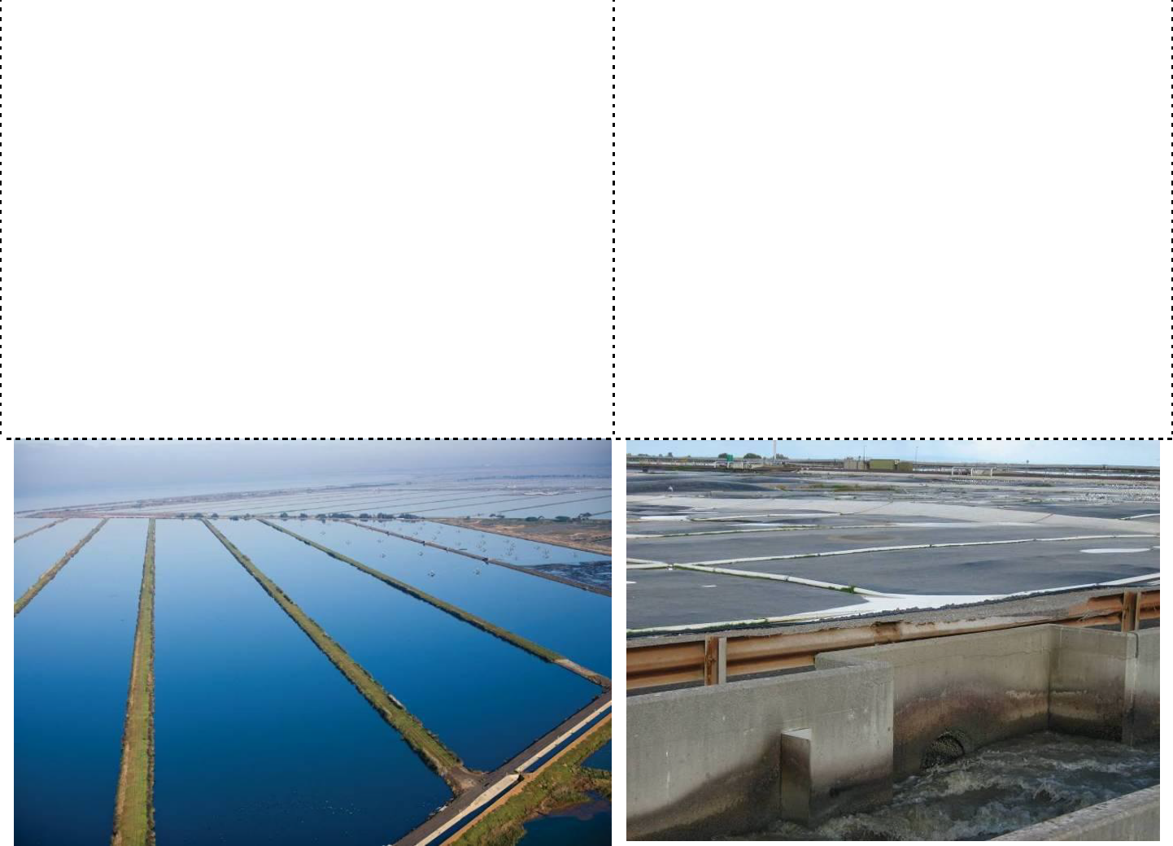
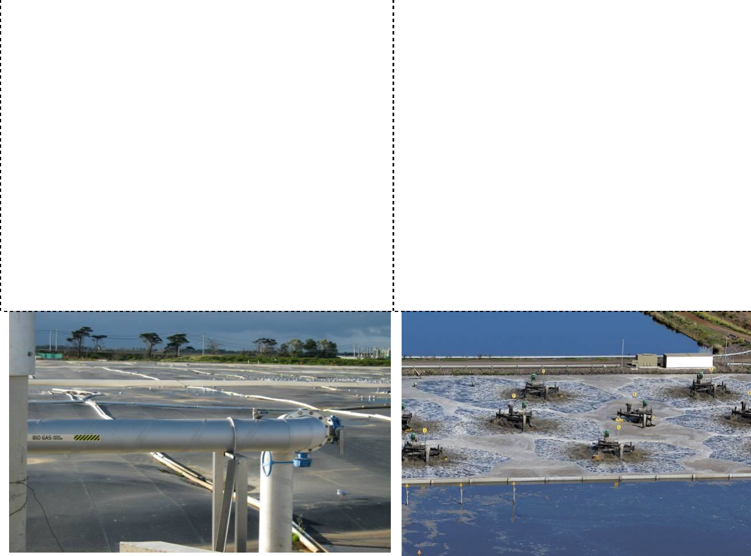
Note: Provide images in random order.

Effluent entering Western Treatment Plant Pumping station

Ponds where water is exposed to sunlight Ponds where sedimentation takes place

Ponds covered with black plastic to capture methane
Mechanical beaters

Conservation lagoon Excess methane gas being burned

Weir where water flows from one pond to another via gravity flow
Open channel leading out to Port
Phillip Bay

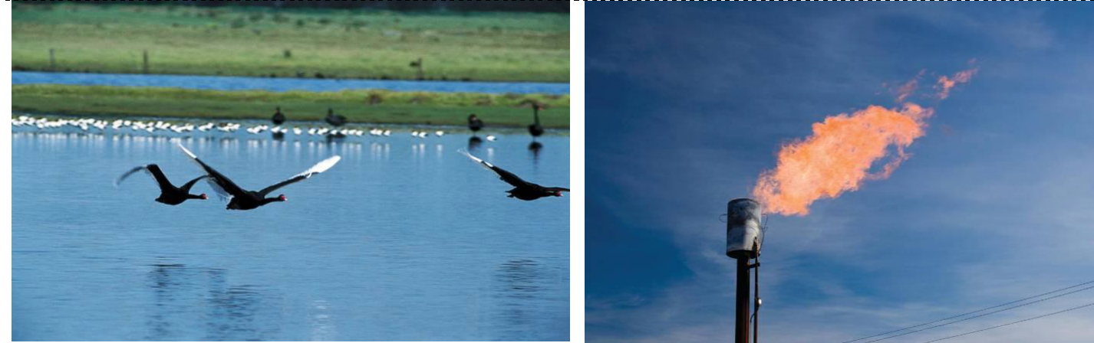
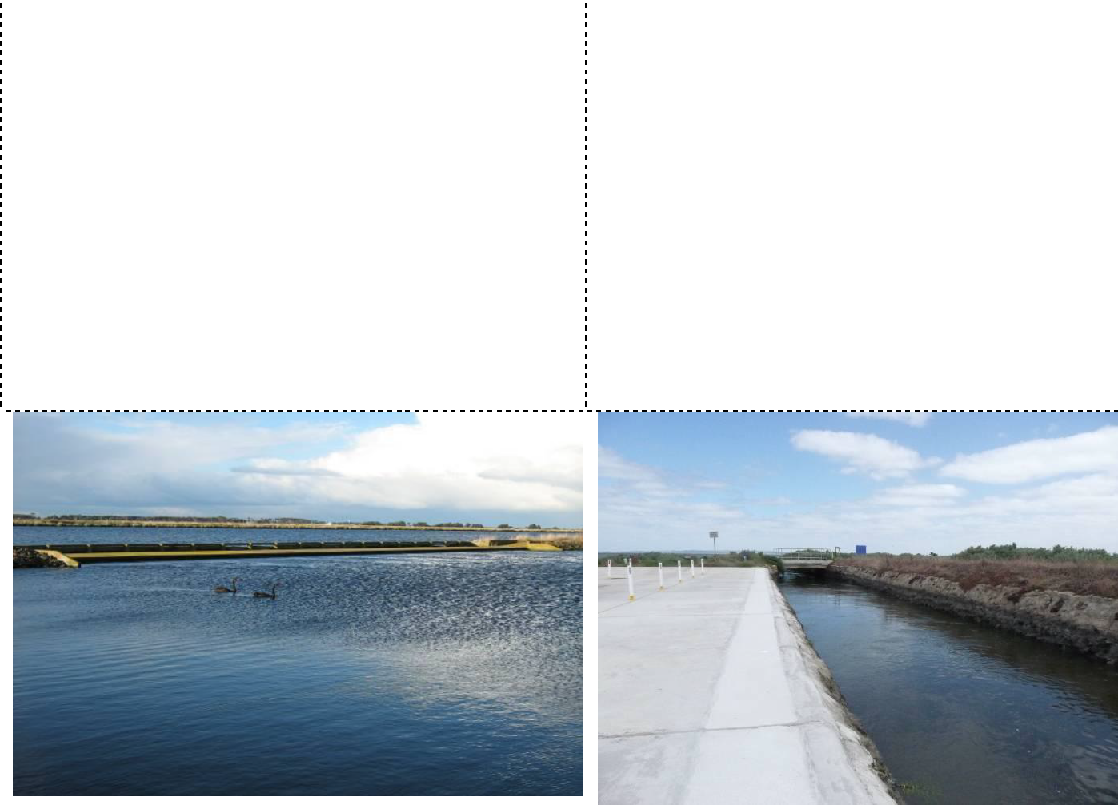
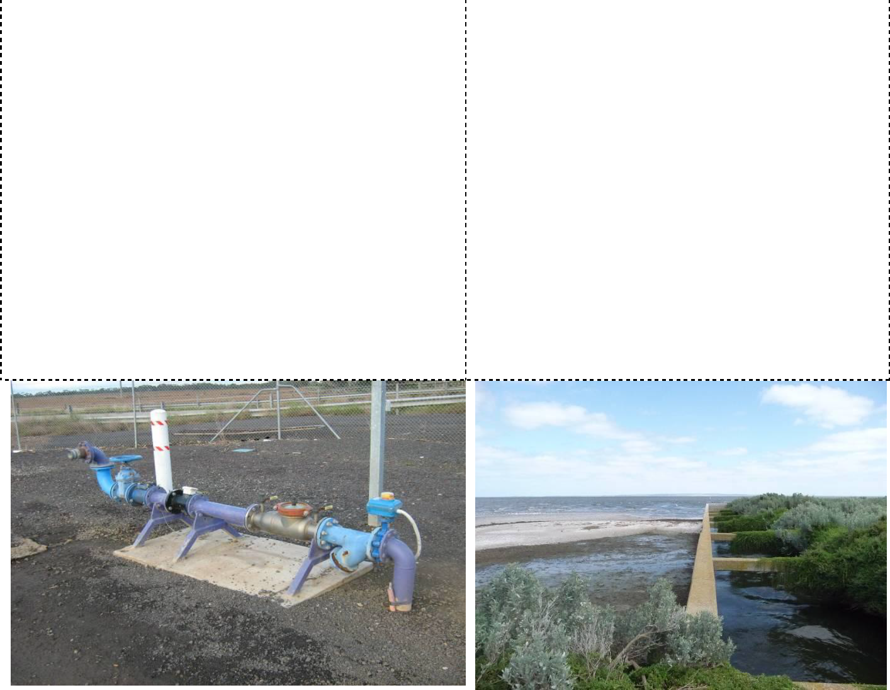

Recycled water standpipe Outfall at Port Phillip Bay

Victorian Curriculum and Assessment Authority (VCAA) <http://victoriancurriculum.vcaa.vic.edu.au/> Accessed 14 August 2016.

